**Project Proposal:** *PHP-SRePS*

|  |  |
| --- | --- |
| 3.1P | **101131147 | MONIQUE KUHN**  Naurin Afrin| Friday 12.30  SWE30010 Development Project 2: Design, planning and Management |

**Background**

Please visit the project documentation generated up till this point at:

<https://github.com/Wabi-Mink/DP2_pass/wiki>

**Resources**

* <https://existek.com/blog/web-application-architecture/>
* <https://existek.com/java-application-development-services/>
* <https://www.devteam.space/blog/why-should-you-use-java-for-your-backend-infrastructure/>

**Solution Direction**

The team proposes the development of a desktop application which interfaces with a database. The database will enable storage and manipulation of sales data.

There are numerous ways to achieve this, and selecting the best option depends on the team’s abilities and suitability of the solution. Some possible routes include:

* Storing Data locally
* Hosting database on mySQL
* Ruby and Rails web application
* Using windows forms for application
* Storing data with cloud-based solutions
* Outsourcing and using a GUI for front end development
* Java web app

In this document, I am proposing a Java-based web application for the following reasons:

* Versatile framework
* Well documented online with many resources
* It is acclaimed to be simple & easy learn which is suitable for a team with varying experience
* Most students involved in the project have experience with C/C++ which rings similar to Java
* It is considered a secure language
* It supports object-oriented programming and multithreading

In such an application the following elements will be required:

|  |  |  |
| --- | --- | --- |
| Element | Brief Description | Roles/Responsibilities |
| Web Browser | software application for accessing information | Access the website and interact as designed |
| Web Container | Manages lifecycle of servlets; handling requests and access-rights | Servlets don’t have a main() method so the container loads them |
| EJB Container | The *Enterprise java bean* contains business logic | Life cycle management, security, transaction management, object pooling |
| Database | Structured set of data held in a computer | Organizes data; storing & accessing requested information as required |

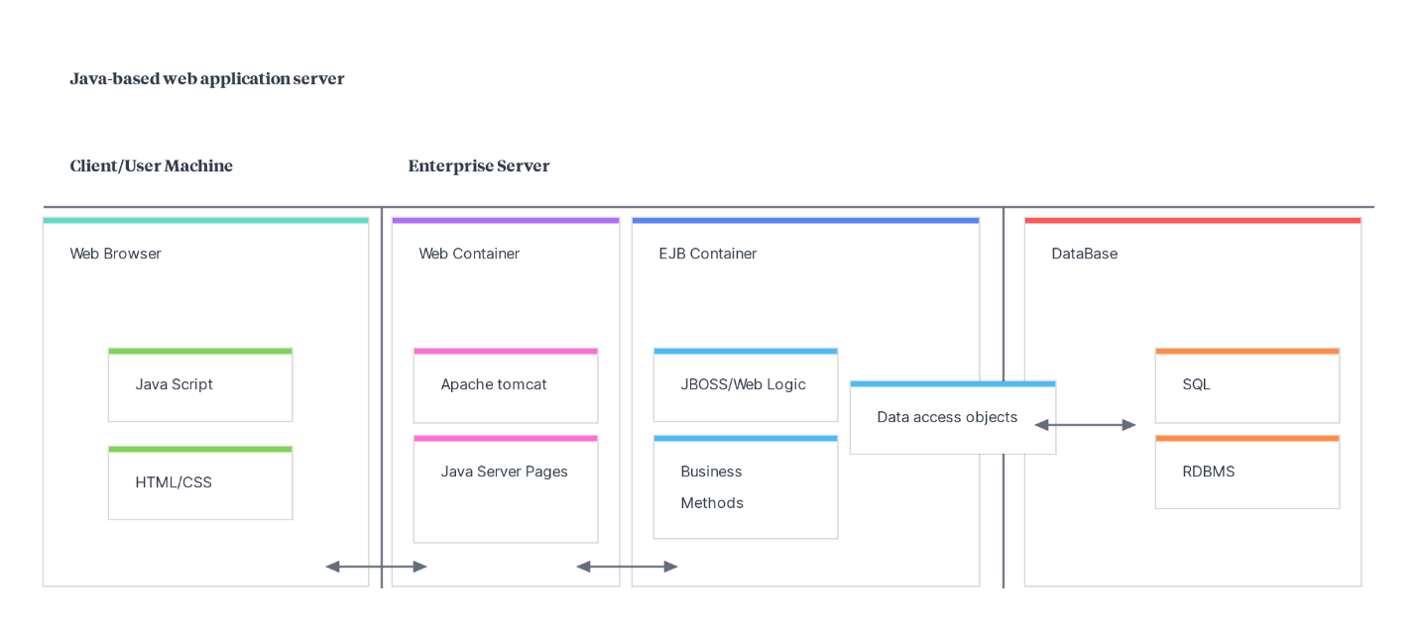

<https://app.milanote.com/1K7ROS1SGrQ97R?p=JR94gNjLNnD>

